AI StudyBuddy AI assistant for smarter learning and study support.
PROJECT DOCUMENTATION:

Team ID: SWTID-2026-5609

Team Leader: SHAHEERA BHANU S & shaheerabhanu1507@gmail.com

Team Members: JEEVITHA K & jeevikjeevitha8@gmail.com

Team Members: SHOBANA PATRA G & shobanapatra02@gmail.com

Team Members: POOJA N & pooja24nagarajan@gmail.com

AI StudyBuddy AI assistant for smarter learning and study support.

Description
AI StudyBuddy is an intelligent web-based learning support platform designed to help students organize their study materials and improve their preparation using Artificial Intelligence. The system combines modern backend technologies with Generative AI to automate common academic activities such as summarization, flashcard creation, quiz generation, and personalized study planning.
The backend is developed using Node.js and Express.js and follows a modular RESTful API architecture. MongoDB is used as the primary database, while Mongoose provides data modeling and database interaction. The system uses JWT authentication to protect user accounts and secure API resources. Role-Based Access Control (RBAC) is implemented to provide different permissions for students and administrators.
Password security is maintained using bcryptjs, which hashes passwords before storing them in the database. The application integrates the Google Gemini AI API to generate educational content dynamically based on the learning material submitted by the user.
The modular architecture separates authentication, routing, business logic, database operations, and AI processing. This makes the system easier to maintain, test, extend, and integrate with additional learning features in the future.

Scenario-Based Case Study

Background
Jeevitha k is a college student preparing for semester examinations while also developing technical skills for internships and future employment. Her learning resources are distributed across PDF files, classroom notes, textbooks, websites, and personal documents.
Because the materials are spread across different sources, she spends considerable time organizing notes and preparing revision materials. She also finds it difficult to decide which topics are important and how much time should be allocated to each subject.
An AI-based learning platform can reduce this manual effort by organizing study materials and automatically generating useful revision resources.

Problem
Jeevitha k faces several difficulties during her preparation:
- Large study materials are difficult to understand and revise quickly.
- Preparing short notes manually requires additional time.
- Creating flashcards for every topic is repetitive.
- Preparing practice questions manually is time-consuming.
- Students may not know how to divide their available study time effectively.
- Study resources are often stored across multiple applications.
- There is limited opportunity for quick self-assessment.
- Students need a centralized platform to manage their learning resources securely.

Solution
AI StudyBuddy provides a centralized learning environment where students can submit study materials and use Artificial Intelligence to create useful academic resources.
The backend receives requests through secure REST APIs and processes them using separate modules. The Google Gemini AI service analyzes the supplied learning content and generates appropriate educational resources.
The system provides the following capabilities:
- Secure registration and login using JWT authentication.
- Storage and management of study materials using MongoDB.
- Automatic generation of topic summaries.
- Creation of question-and-answer flashcards.
- Generation of multiple-choice practice quizzes.
- Creation of personalized study schedules.
- Secure storage of generated learning resources.
- Role-based access for students and administrators.
- Retrieval of previously generated resources for revision.
The separation of authentication, controllers, database models, and AI services makes the application modular and easier to maintain.

Usage

Student Usage
Students first create an account and log in to the application. After successful authentication, they can upload study materials or enter learning content manually.
Students can select the required AI service and generate:
- Summaries
- Flashcards
- Quizzes
- Study plans
The generated resources can be reviewed and stored for later revision. Students can also access their previously uploaded materials and generated resources through the application.

Administrator Usage
Administrators are responsible for maintaining the platform and managing user-related activities.
Administrative operations include:
- Managing registered users.
- Monitoring application activity.
- Managing user permissions.
- Monitoring system usage.
- Reviewing application logs.
- Maintaining platform security.
- Managing administrative resources.

Outcome:
AI StudyBuddy reduces the amount of manual work involved in preparing study resources. Students can spend more time understanding concepts instead of repeatedly preparing notes, questions, and revision materials.
The combination of Node.js, Express.js, MongoDB, JWT authentication, and Google Gemini AI provides a flexible foundation for developing an intelligent learning platform.
The modular backend design also allows future features such as document processing, progress tracking, recommendation systems, performance analytics, and additional AI learning tools to be added without redesigning the complete application.
As a result, AI StudyBuddy provides a centralized and intelligent environment that supports students in organizing their academic resources and improving their revision process.

Software Requirements

• Operating System: Windows 10/11, macOS, or Linux.
• Node.js: Version 16 or later for executing the backend application.
• npm: Version 8 or later for dependency management.
• Express.js: Backend framework for developing REST APIs.
• MongoDB: NoSQL database for storing application data.
• Mongoose: ODM library for MongoDB schema management and database operations.
• Postman: Tool for testing and validating REST API endpoints.
• Visual Studio Code: Recommended code editor for backend development.
• Google Gemini API: Used for AI-powered educational content generation.

Hardware Requirements

• Processor: Intel Core i5 8th Generation or equivalent AMD Ryzen 5 and above.
• RAM: Minimum 8 GB; 16 GB recommended for smoother development.
• Storage: Minimum 1 GB of free storage space.
• Internet Connection: Required for accessing cloud-based AI services and MongoDB services when applicable.

Epic 1: Project Architecture
The AI StudyBuddy backend follows a modular REST API architecture that connects the React frontend, Express.js server, MongoDB database, authentication system, and Google Gemini AI service.
The architecture is designed to separate different responsibilities into independent components. This improves maintainability, security, scalability, and debugging.
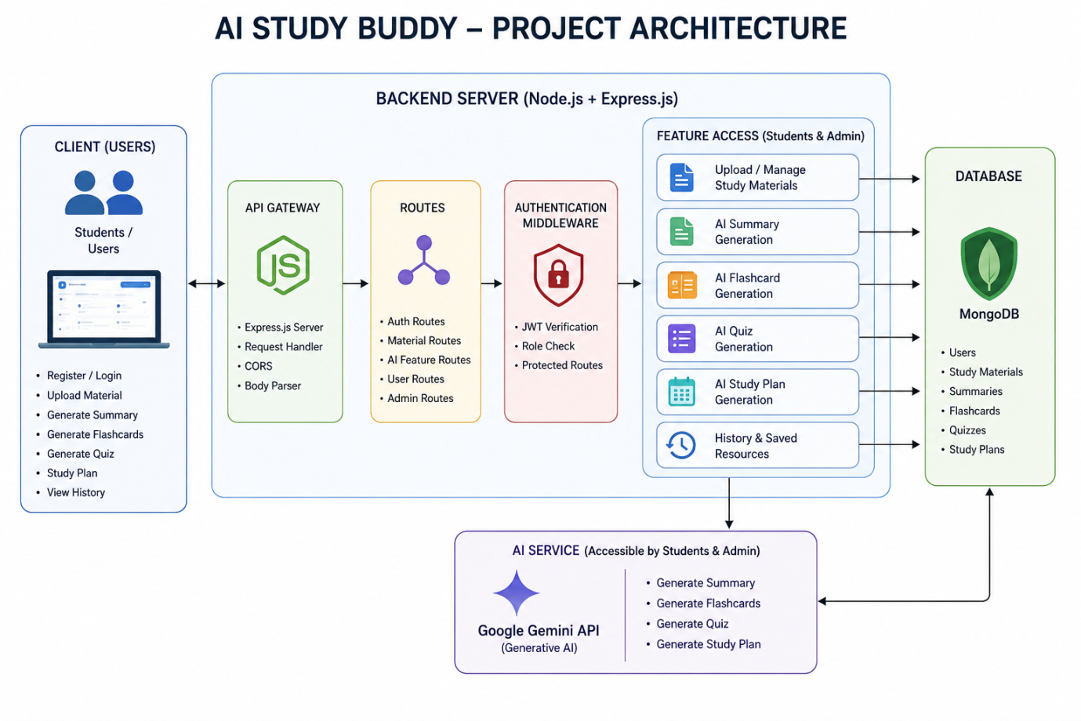

Components Definition

Client Application
The React-based frontend provides the user interface through which students can register, log in, upload study materials, and request AI-generated learning resources.

Express Server
The Express.js server receives client requests, processes middleware, identifies the requested API route, and returns appropriate responses.

Authentication Middleware
JWT-based authentication verifies the identity of users before allowing access to protected resources. Authorization checks are used to restrict administrator-only operations.

Route Handlers
API routes organize endpoints related to authentication, study materials, AI services, and administrative functions.

AI Service Layer
The AI service communicates with the Google Gemini API. It prepares suitable prompts and sends learning content to the AI model to generate summaries, flashcards, quizzes, and study plans.

Database Layer
MongoDB stores user information, study materials, and generated learning resources. Mongoose is used to define schemas and perform database operations.

Entity-Relationship (ER) Diagram Description
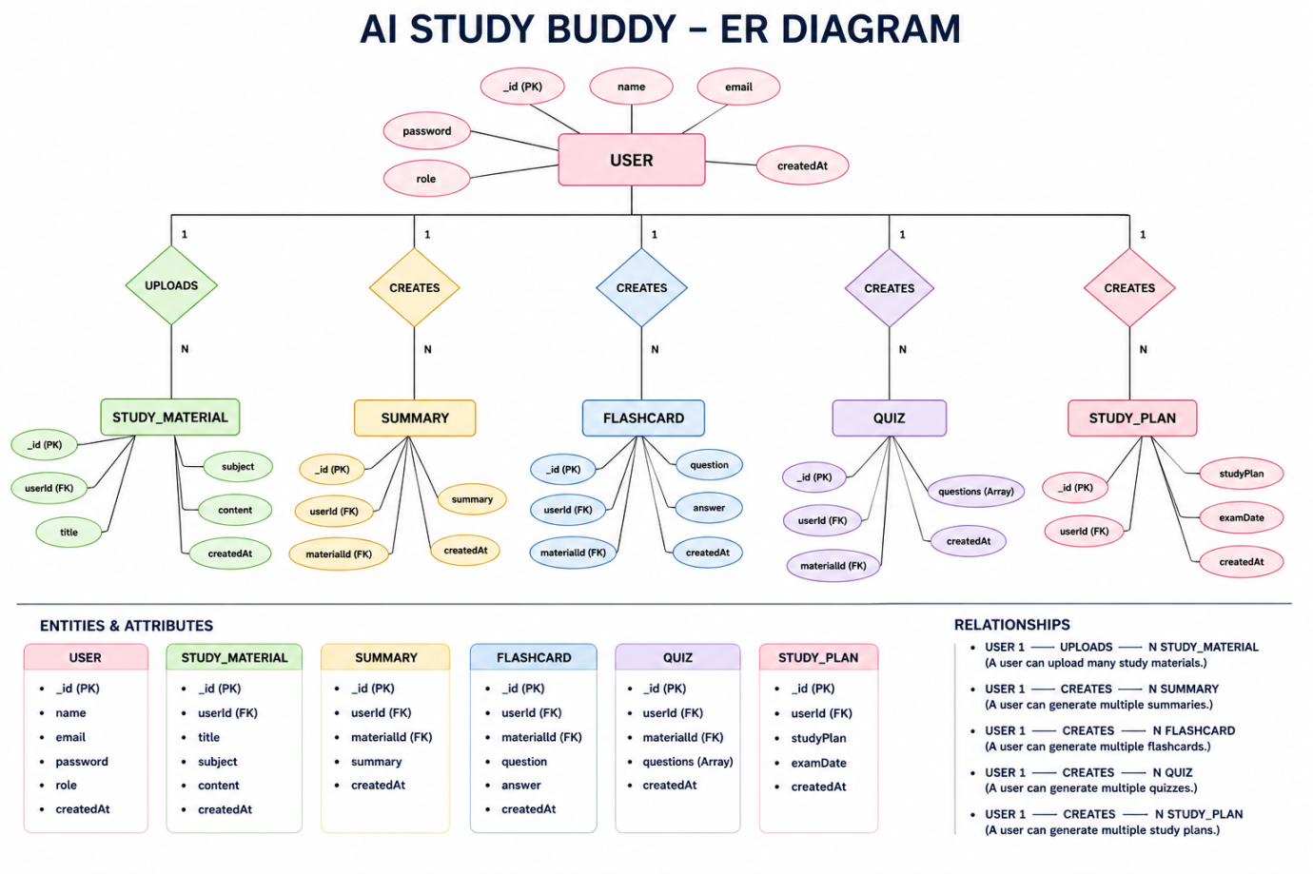
The database consists of multiple logically connected entities. These entities allow the system to associate users with their study materials and AI-generated resources.

1. User Entity
The User entity contains account and authentication information.
Attributes:
- _id – Primary Key / ObjectId
- name – User name
- email – Unique email address
- password – Hashed password
- role – Student or Admin
- createdAt – Account creation date

2. Study Material Entity
This entity stores the academic content submitted by users.
Attributes:
- _id – Primary Key
- userId – Reference to User
- title – Material title
- subject – Subject name
- content – Learning content
- createdAt – Upload date

3. Summary Entity
This entity stores AI-generated summaries associated with study materials.
Attributes:
- _id
- userId
- materialId
- summary
- createdAt

4. Flashcard Entity
This entity stores individual AI-generated flashcards.
Attributes:
- _id
- userId
- materialId
- question
- answer
- createdAt

5. Quiz Entity
The Quiz entity contains questions generated from a selected study material.
Attributes:
- _id
- userId
- materialId
- questions
- createdAt

6. Study Plan Entity
The Study Plan entity stores customized schedules generated according to the student's requirements.
Attributes:
- _id
- userId
- studyPlan
- examDate
- createdAt

Key Relationships
- A single User can have multiple Study Materials.
- A Study Material can be associated with generated summaries.
- A Study Material can produce multiple Flashcards.
- A Study Material can be associated with generated quizzes.
- A User can create multiple Study Plans.
- All AI-generated resources are associated with the corresponding user.

Key Features
The major features of the AI StudyBuddy backend include:

Secure Authentication
The application uses JWT tokens to authenticate users and protect private APIs.

Password Protection
Passwords are hashed using bcryptjs before they are stored in the database.

Study Material Management
Students can upload, store, retrieve, and manage learning materials.

AI Summary Generation
The Gemini AI service converts lengthy learning content into shorter revision-friendly summaries.

Flashcard Generation
The system automatically generates question-and-answer cards to support active recall.

Quiz Generation
Multiple-choice questions are generated from study materials for self-assessment.

Personalized Study Planning
The system creates study schedules according to subjects, available time, and examination dates.

Role-Based Access Control
Students and administrators receive different permissions based on their assigned roles.

Centralized Data Storage
MongoDB provides centralized storage for user accounts, learning materials, and generated resources.

Roles and Responsibilities

Student
Students are the main users of the platform.
They can:
- Create an account.
- Log in securely.
- Upload study materials.
- Generate summaries.
- Create flashcards.
- Generate quizzes.
- Create personalized study plans.
- View previously generated resources.
- Manage their learning materials.

Administrator
Administrators are responsible for system-level management.
They can:
- View registered users.
- Manage user accounts.
- Monitor application activity.
- Control user roles and permissions.
- Review system usage.
- Maintain platform security.
- Support overall backend operations.

User Flow
The application starts when a student registers for an account or logs into an existing account.
After successful authentication, the server provides a JWT token that is used to access protected APIs.
The student can then upload study material or provide textual content. The selected AI operation is sent to the backend, where the AI service communicates with Google Gemini.
The generated output is returned to the frontend and can also be stored in MongoDB for future access.
The overall process is:
Register/Login → Authentication → Dashboard → Upload Material → Select AI Feature → Gemini Processing → Generate Resource → Store Resource → View/Revise
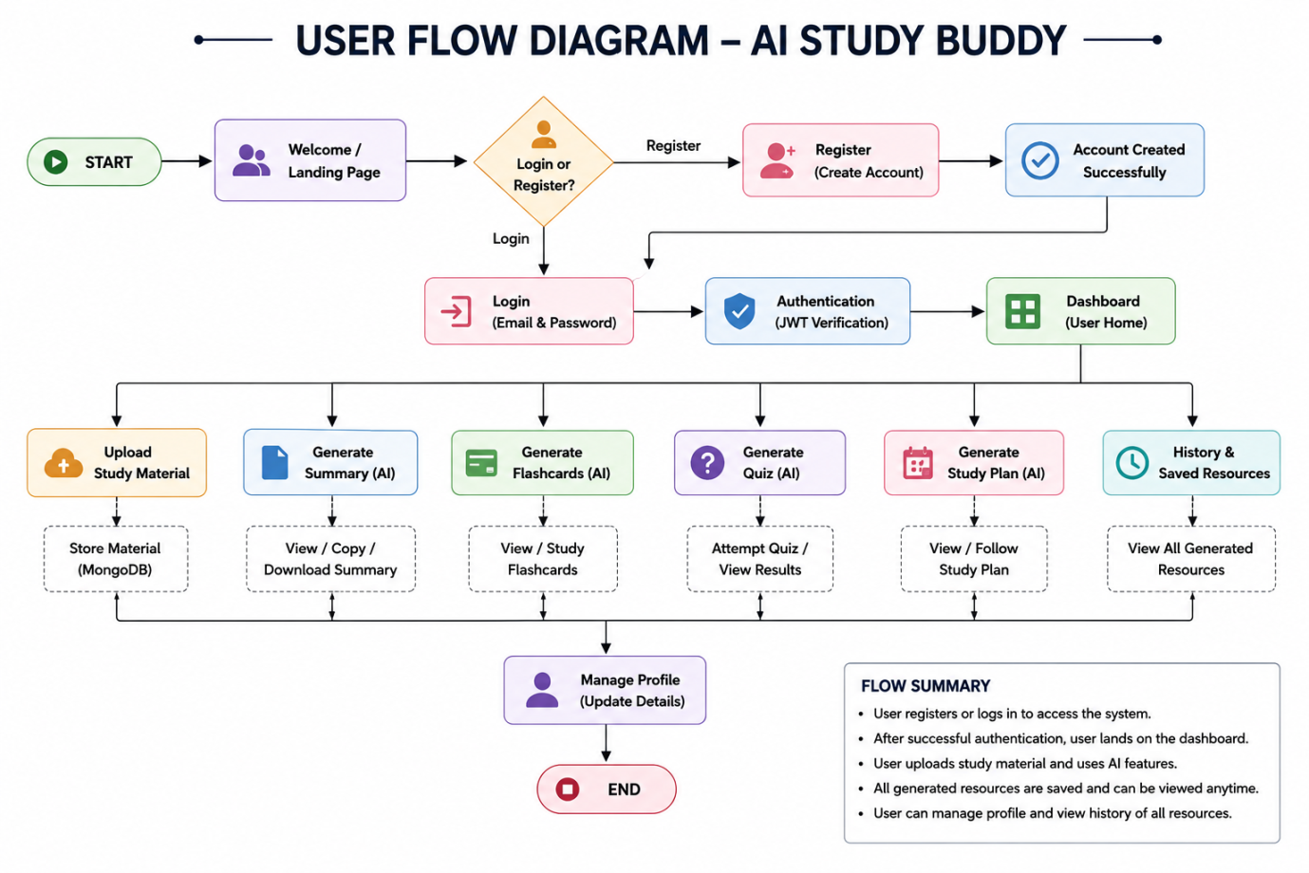

MVC Architecture Pattern
The AI StudyBuddy backend follows the MVC architecture pattern to divide the application into logical layers.
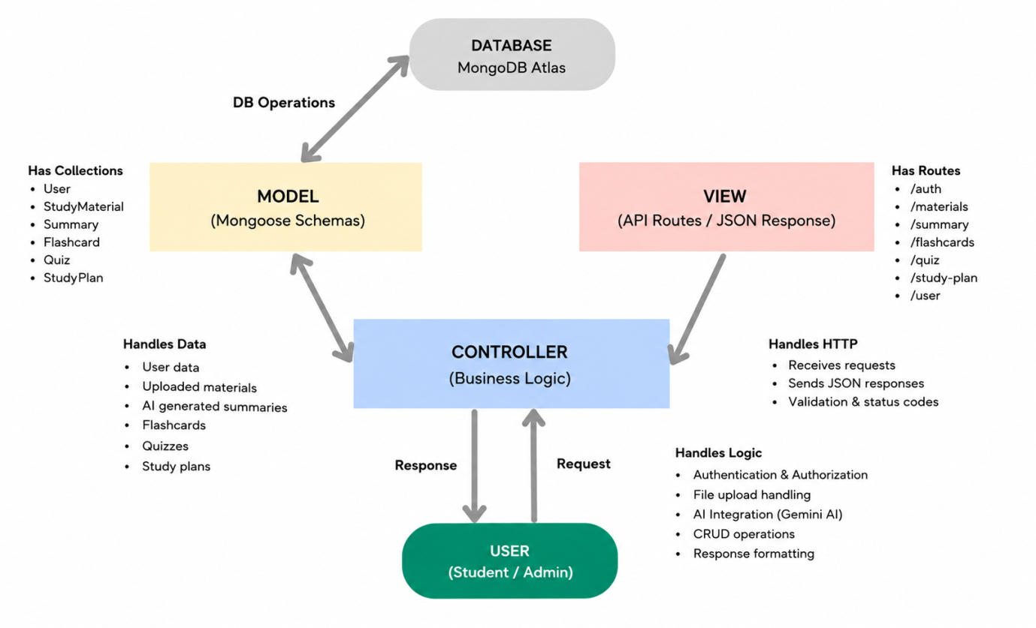

Model Layer
The Model layer contains Mongoose schemas used to represent application data.
It manages:
- User information
- Study materials
- Summaries
- Flashcards
- Quizzes
- Study plans
The Model layer also performs database validation and communication with MongoDB.

View Layer
Since the application uses a REST API architecture, there is no traditional server-side HTML view.
Instead, the backend returns structured JSON responses that are consumed by the React frontend.

Controller Layer
The Controller layer contains the application's main business logic.
It is responsible for:
- Processing requests.
- Validating input.
- Checking authentication.
- Performing authorization.
- Communicating with database models.
- Calling the Gemini AI service.
- Preparing API responses.

MVC Benefits
The MVC approach provides several advantages:
- Better code organization.
- Easier debugging.
- Improved maintainability.
- Separation of responsibilities.
- Easier testing.
- Simplified future development.
- Better scalability.

Model Layer
The Model layer contains Mongoose schemas used to represent application data.
It manages:
- User information
- Study materials
- Summaries
- Flashcards
- Quizzes
- Study plans
The Model layer also performs database validation and communication with MongoDB.

View Layer
Since the application uses a REST API architecture, there is no traditional server-side HTML view.
Instead, the backend returns structured JSON responses that are consumed by the React frontend.

Controller Layer
The Controller layer contains the application's main business logic.
It is responsible for:
- Processing requests.
- Validating input.
- Checking authentication.
- Performing authorization.
- Communicating with database models.
- Calling the Gemini AI service.
- Preparing API responses.

MVC Benefits
The MVC approach provides several advantages:
- Better code organization.
- Easier debugging.
- Improved maintainability.
- Separation of responsibilities.
- Easier testing.
- Simplified future development.
- Better scalability.

Model Layer
The Model layer contains Mongoose schemas used to represent application data.
It manages:
- User information
- Study materials
- Summaries
- Flashcards
- Quizzes
- Study plans
The Model layer also performs database validation and communication with MongoDB.

View Layer
Since the application uses a REST API architecture, there is no traditional server-side HTML view.
Instead, the backend returns structured JSON responses that are consumed by the React frontend.

Controller Layer
The Controller layer contains the application's main business logic.
It is responsible for:
- Processing requests.
- Validating input.
- Checking authentication.
- Performing authorization.
- Communicating with database models.
- Calling the Gemini AI service.
- Preparing API responses.

MVC Benefits
The MVC approach provides several advantages:
- Better code organization.
- Easier debugging.
- Improved maintainability.
- Separation of responsibilities.
- Easier testing.
- Simplified future development.
- Better scalability.

Epic 2: Project Setup and Configuration

Project Initialization
Execute the following command:
npm init -y
Install the required packages:
npm install express mongoose bcryptjs jsonwebtoken cors dotenv multer @google/genai
Install Nodemon for development:
npm install --save-dev nodemon

Project Files
Create the following files:
- index.js
- .env
- package.json
- .gitignore
Create the required source folders for:
- Routes
- Controllers
- Models
- Middleware
- Utilities
- Services


Environment Configuration
Create a .env file in the project root and configure the required environment variables.
PORT=5000
MONGO_URI=your_mongodb_connection_string
JWT_SECRET=your_jwt_secret
GEMINI_API_KEY=your_gemini_api_key

Epic 3: Backend Development
The AI StudyBuddy backend is developed using Node.js, Express.js, and MongoDB, following a modular architecture. The application separates routing, controllers, middleware, models, and utility modules to improve code maintainability and scalability. The backend exposes secure REST APIs for authentication, study material management, AI-powered content generation, and administrative operations.


1. Application Entry Point – index.js
The index.js file is the starting point of the backend application.
Its responsibilities include:
- Loading environment variables.
- Creating the Express application.
- Configuring middleware.
- Connecting to MongoDB.
- Registering API routes.
- Starting the HTTP server.
The server begins accepting requests after the required configuration and database connection are established.


2. Database Connection – src/utils/db.js
The database utility establishes communication between the Node.js application and MongoDB using Mongoose.
It provides a centralized connection mechanism and helps handle database connection errors.



3. Authentication Middleware – src/middleware/auth.js
The authentication middleware reads the JWT token provided by the client and verifies it.
After successful verification, the authenticated user's information can be used by protected controllers.
The middleware can also check the user's role before allowing access to administrative APIs.


4. AI Integration – src/utils/gemini.js
The Gemini utility communicates with the Google Gemini API.
It receives appropriate prompts and learning content and returns AI-generated responses.
The service can be used for:
- Summaries
- Flashcards
- Quizzes
- Study plans


5. File Upload Middleware – src/middleware/upload.js
The upload middleware handles files submitted by students.
It validates incoming files and prepares them for further processing by the backend.


Epic 4: Database Configuration
The AI StudyBuddy system uses MongoDB as its primary database.
MongoDB provides flexible document-based storage, while Mongoose is used to define schemas and simplify database operations.

Configure MongoDB
Install Mongoose using:
npm install mongoose

Database Connection
The backend establishes the MongoDB connection when the application starts.
The database connection module is responsible for:
- Connecting to MongoDB.
- Handling connection errors.
- Maintaining database communication.
- Allowing other modules to perform database operations.

Mongoose Schema Definitions

1. User Schema – models/User.js
The User schema defines the structure of user account information.
It contains fields such as:
- Name
- Email
- Password
- Role
- Creation date
The password is hashed before being stored.


2. Study Material Schema – models/Material.js
The Study Material schema stores the academic content submitted by students.
The material can later be used as input for AI-powered operations.


Database Collections
The primary collections used by the system include:
- Users – Stores account information.
- Study Materials – Stores learning content.
- Summaries – Stores generated summaries.
- Flashcards – Stores generated flashcards.
- Quizzes – Stores generated quiz data.
- Study Plans – Stores personalized schedules.

API Route Interface Endpoints
The backend provides RESTful endpoints for communication between the frontend and server.

1. Authentication APIs
Authentication endpoints handle:
- User registration.
- User login.
- JWT generation.
- Authentication verification.
- Protected resource access.

2. Study Material APIs
These endpoints allow students to:
- Upload materials.
- Retrieve materials.
- Update materials.
- Delete materials.
- View previously stored content.

3. AI Feature APIs
The AI service provides endpoints for:
- Summary generation.
- Flashcard generation.
- Quiz generation.
- Study plan generation.

4. Administrative APIs
Administrator-only endpoints support:
- User management.
- Application monitoring.
- User activity management.
- System-level operations.

Epic 5: Project Execution
The AI StudyBuddy backend can be executed locally using Node.js.
Before starting the application, the developer should ensure that the required dependencies are installed, MongoDB is available, and environment variables have been configured correctly.

Running the Backend Server
Install project dependencies:
npm install
Start the development server:
npm start
If Nodemon is configured as the development script, the server can also be started using:
npm run dev
After successful startup, the Express server listens for incoming API requests and communicates with MongoDB as required.

API Testing
The AI StudyBuddy backend APIs are tested using Postman to verify request processing, authentication, data validation, database operations, and AI service integration. Each API is tested with the required input parameters and the response is checked to ensure that the backend functions correctly.

1. User Registration
The registration API is used to create a new student account. It accepts the user's basic details, validates the provided information, securely hashes the password, and stores the user record in MongoDB.
Endpoint:
POST /api/auth/register
Purpose:
- Creates a new user account.
- Validates user information.
- Encrypts the password before database storage.
- Returns a successful registration response.

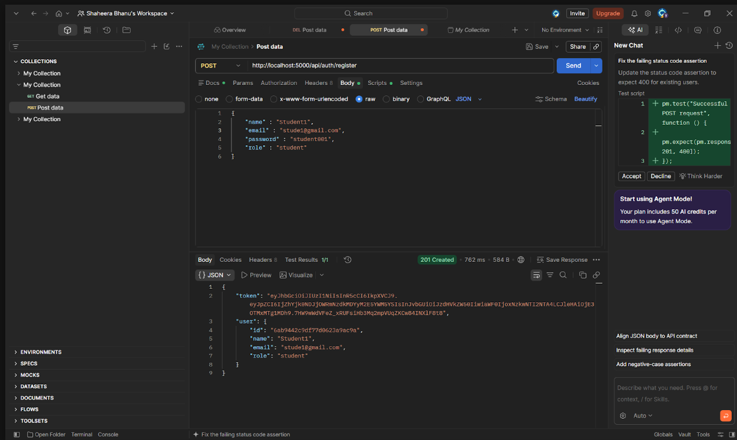

2. User Login
The login API verifies the credentials of an existing user. After successful authentication, the server generates a JWT access token that can be used to access protected resources.
Endpoint:
POST /api/auth/login
Purpose:
- Validates email and password.
- Authenticates the registered user.
- Generates a JWT token.
- Provides access to protected APIs.

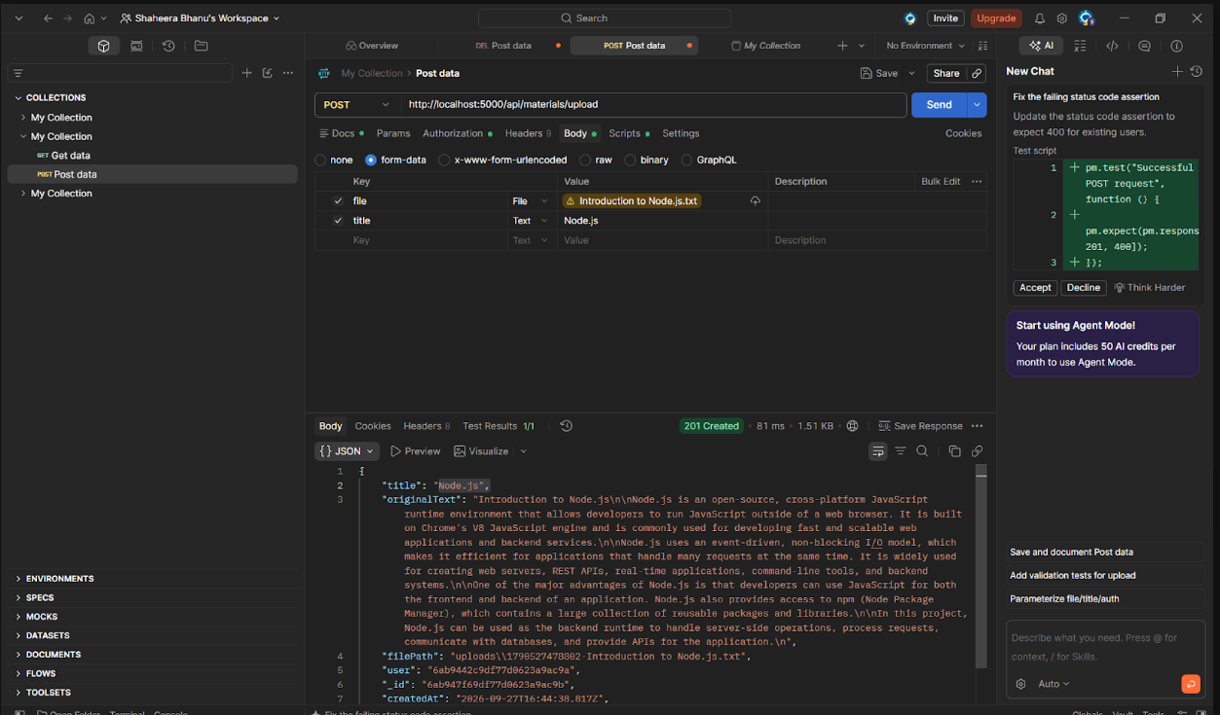

3. Upload Study Material
The study material upload API allows authenticated students to submit their learning content. The uploaded material is stored and can later be processed by the AI services.
Endpoint:
POST /api/material/upload
Purpose:
- Accepts study materials from authenticated users.
- Validates the uploaded content.
- Stores material information in MongoDB.
- Makes the material available for AI processing.

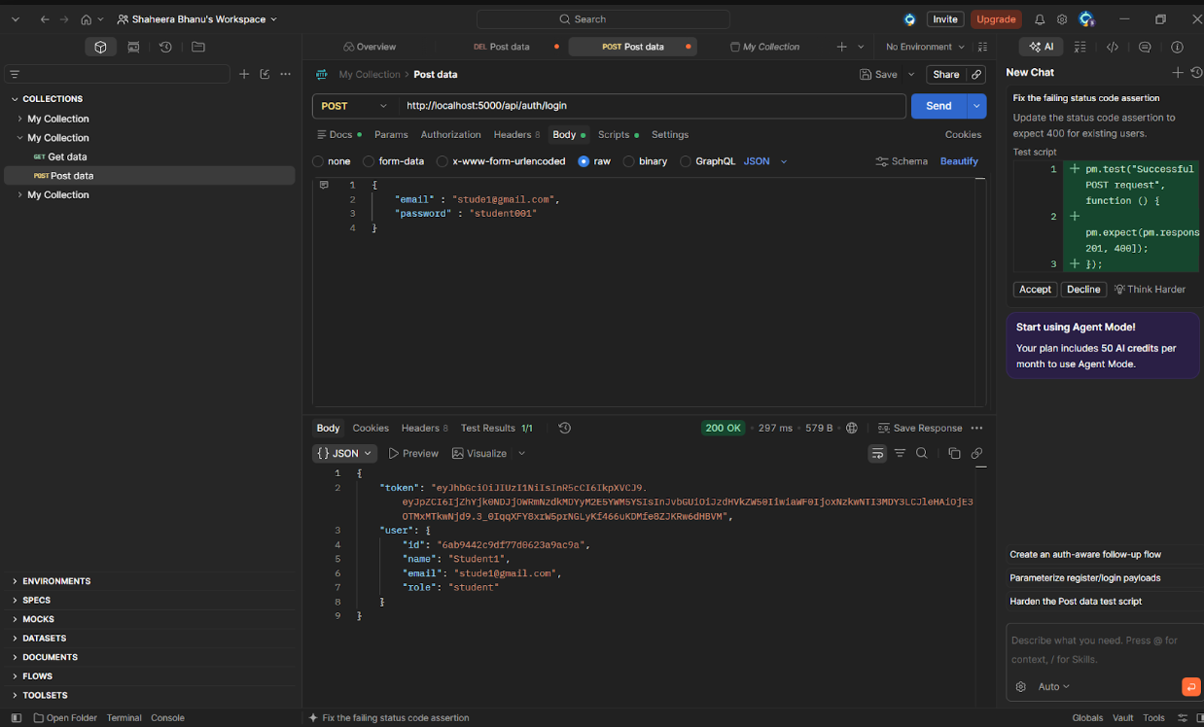

4. Generate AI Summary
The summary API processes a selected study material and sends the relevant content to the Google Gemini AI service. The generated response is returned as a concise summary to help students revise important concepts quickly.
Endpoint:
POST /api/materials/:id/summarize
Purpose:
- Identifies the selected study material.
- Sends the content to the Gemini AI service.
- Generates a concise summary.
- Returns the generated summary to the user.

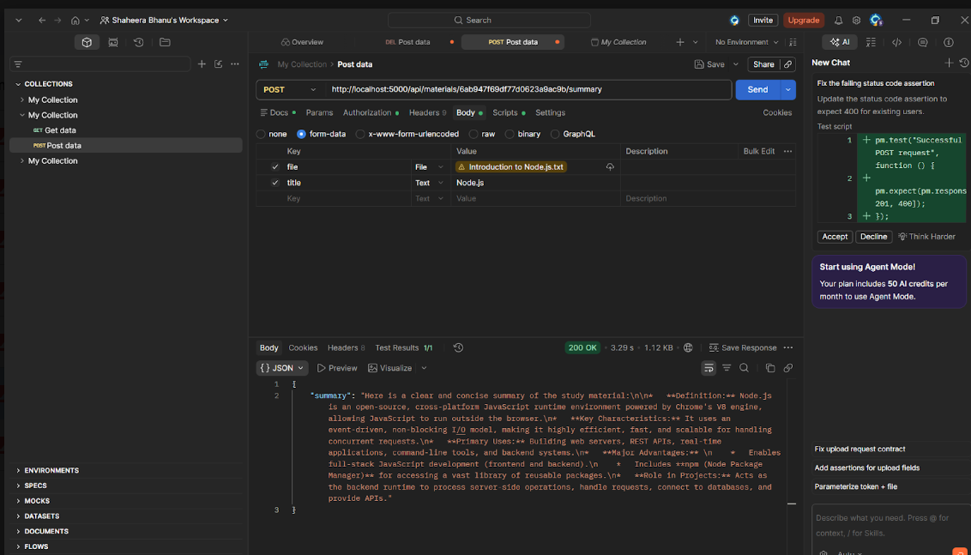

5. Generate AI Flashcards
The flashcard API generates question-and-answer cards from the selected study material. These flashcards support active recall and help students revise important concepts.
Endpoint:
POST /api/ai/flashcards
Purpose:
- Processes the selected learning material.
- Sends the content to the Gemini AI service.
- Generates question-and-answer flashcards.
- Returns the generated flashcards for revision.

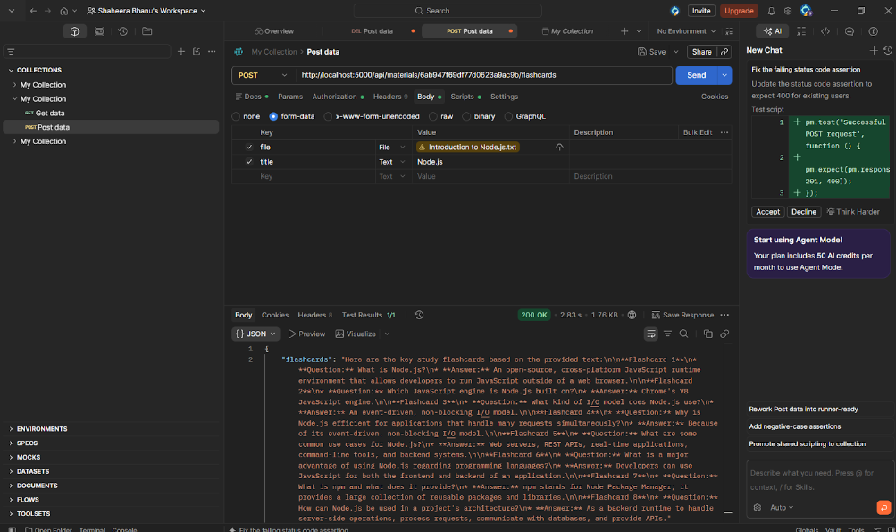

6. Generate AI Quiz
The quiz API creates multiple-choice questions based on the student's study material. It helps users practice the learned concepts and identify areas that require additional revision.
Endpoint:
POST /api/ai/quiz
Purpose:
- Uses study material as the input.
- Generates multiple-choice questions.
- Provides answer options for self-assessment.
- Returns the generated quiz to the user.

- 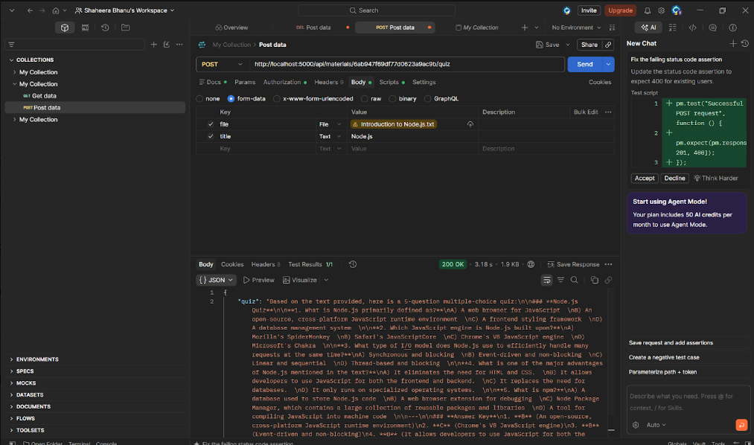

7. Generate AI Study Plan
The study plan API creates a personalized learning schedule based on the student's study requirements, available time, subjects, and examination timeline.
Endpoint:
POST /api/ai/study-plan
Purpose:
- Accepts the user's study preferences.
- Considers available preparation time.
- Uses the Gemini AI service to generate a study schedule.
- Returns a structured plan for regular preparation.

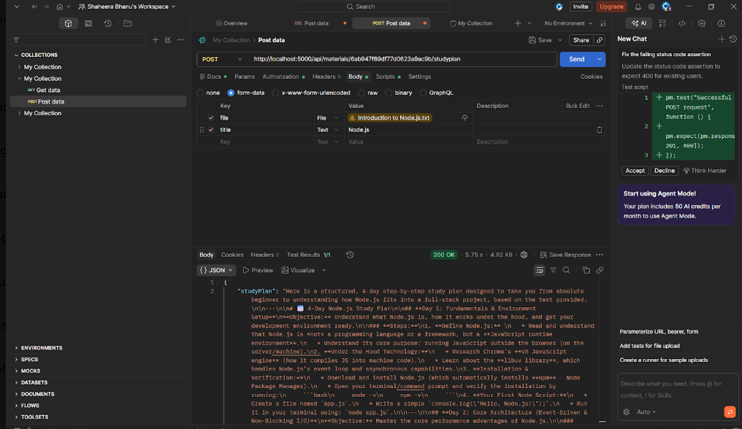

DRIVE LINK: CLICK HERE TO ACCESS DRIVE LINK

DEMO VIDEO LINK: CLICK HERE TO WATCH THE DEMO VIDEO

